

Bodyfat Percentage  
(Regression)

The goal of this study is to train a model in order to predict the percentage of bodyfat in men. The dataset used in this case study is found in <https://www.kaggle.com/datasets/fedesoriano/body-fat-prediction-dataset> and has 14 features and 251 samples. This dataset contains information on certain factors like Density determined from underwater weighing, age, weight, height, neck circumference, Chest circumference, Abdomen 2 circumference, Hip circumference, Thigh circumference, Knee circumference, Ankle circumference, Biceps (extended) circumference, Forearm circumference, Wrist circumference. The dataset contains no missing values and also all features are numerical, therefore there is no need to for transforming any of them.

# Step 1: Import data from file

Right click on the input spreadsheet and choose the option “Import from file”. Then navigate through your files to load the one with the housing price data.

# Step 2: Manipulate data

In order to use the data for training we have to exclude any columns that do not contain features. In our dataset there are no such columns. Therefore, we will include all columns in the training. We follow these steps to execute this:

* On the menu click on “Data Transformation” → “Data Manipulation” → “Select Column(s)”
* Select all columns.

|  |  |
| --- | --- |
|  |  |

The data will appear in the output spreadsheet.

# Step 3: Split data

Create a new tab by pressing the “+” button on the bottom of the page with the name “TRAIN_TEST_SPLIT” which we will use for splitting to create the train and test set.

Import data into the input spreadsheet of the “TRAIN_TEST_SPLIT” tab from the output of the “IMPORT” tab by right-clicking on the input spreadsheet and then choosing “Import from SpreadSheet”.

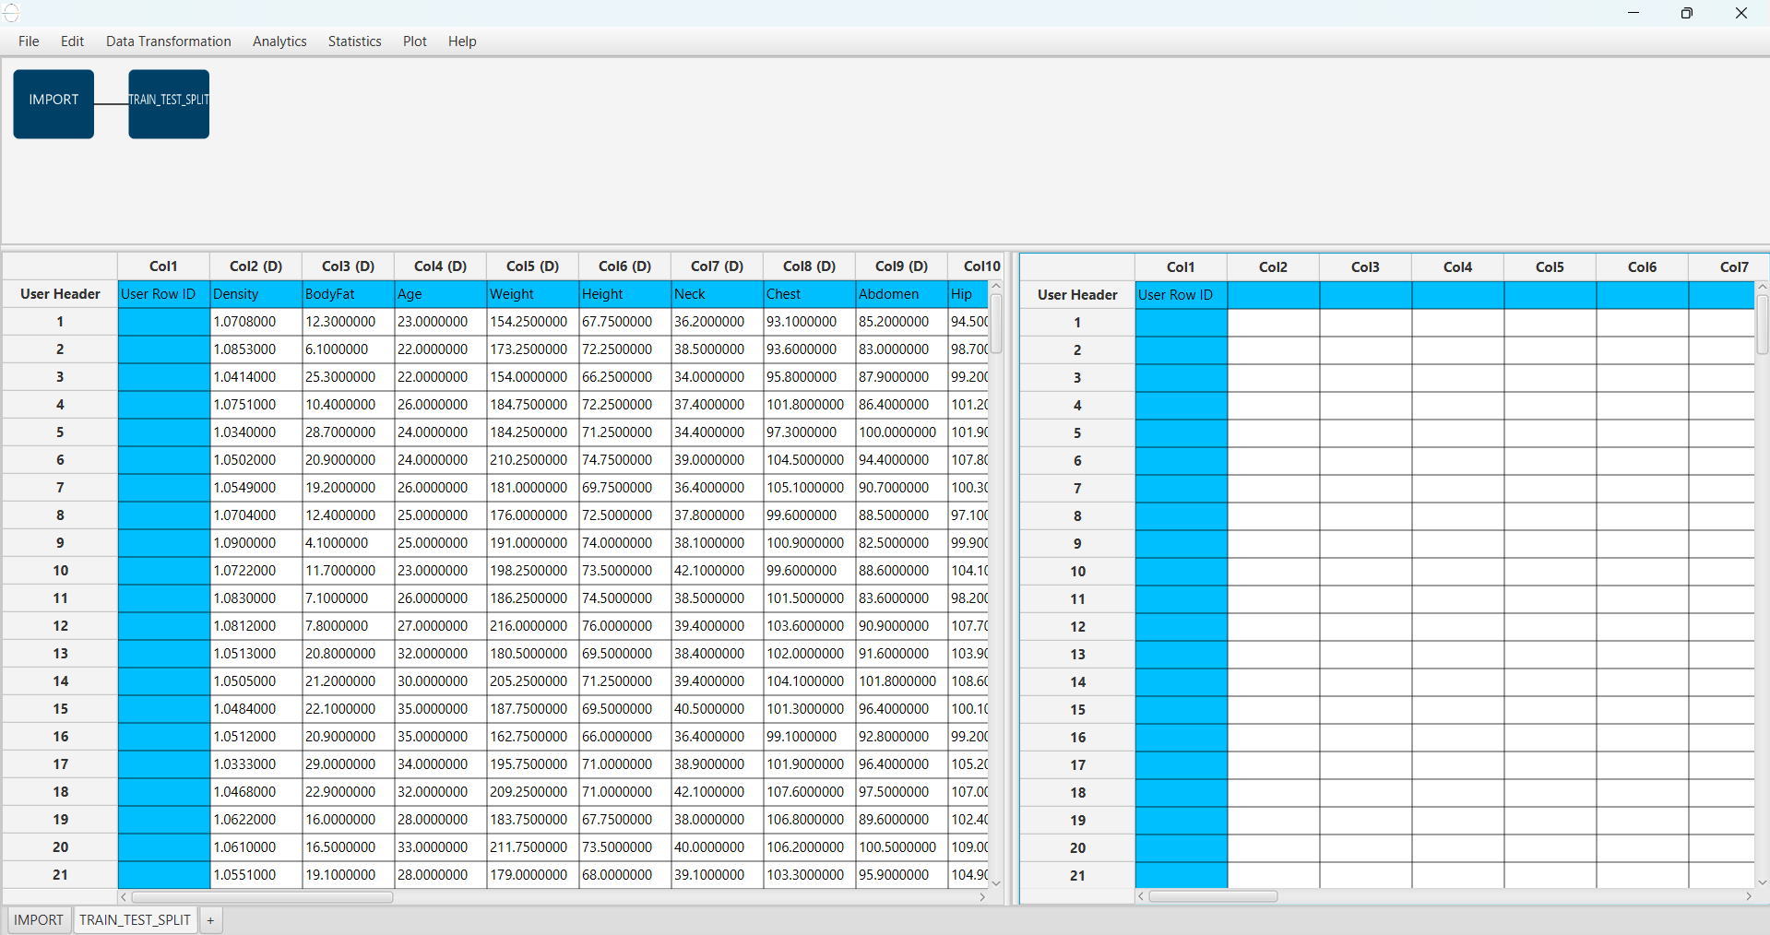

Split the dataset by choosing from the top ribbon: “Data Transformation” → “Split” → “Random Partitioning”. Then choose the “Training set percentage” and the column for the sampling as shown below:

|  |  |
| --- | --- |
|  |  |

The results will appear on the output spreadsheet.

# A screenshot of a computer Description automatically generatedStep 4: Normalize the training set

Create a new tab by pressing the “+” button on the bottom of the page with the name “NORMALIZE_TRAIN_SET”.

Import data into the input spreadsheet of the “NORMALIZE_TRAIN_SET” tab the train set from the output of the “TRAIN_TEST_SPLIT” tab by right-clicking on the input spreadsheet and then choosing “Import from SpreadSheet”. From the available Select input tab options choose “TRAIN_TEST_SPLIT: Training Set”.

Normalize the data using Z-score by browsing: “Data Transformation” → “Normalizers” → “Z-Score”. Then select all columns except “BodyFat” and click “Execute”.

|  |  |
| --- | --- |
|  |  |

The results will appear on the output spreadsheet.

# Step 5: Normalize the test set

Create a new tab by pressing the “+” button on the bottom of the page with the name “NORMALIZE_TEST_SET”.

Import data into the input spreadsheet of the “NORMALIZE_TEST_SET” tab the test set from the output of the “TRAIN_TEST_SPLIT” tab by right-clicking on the input spreadsheet and then choosing “Import from SpreadSheet”. From the available Select input tab options choose “TRAIN_TEST_SPLIT: Test Set”.

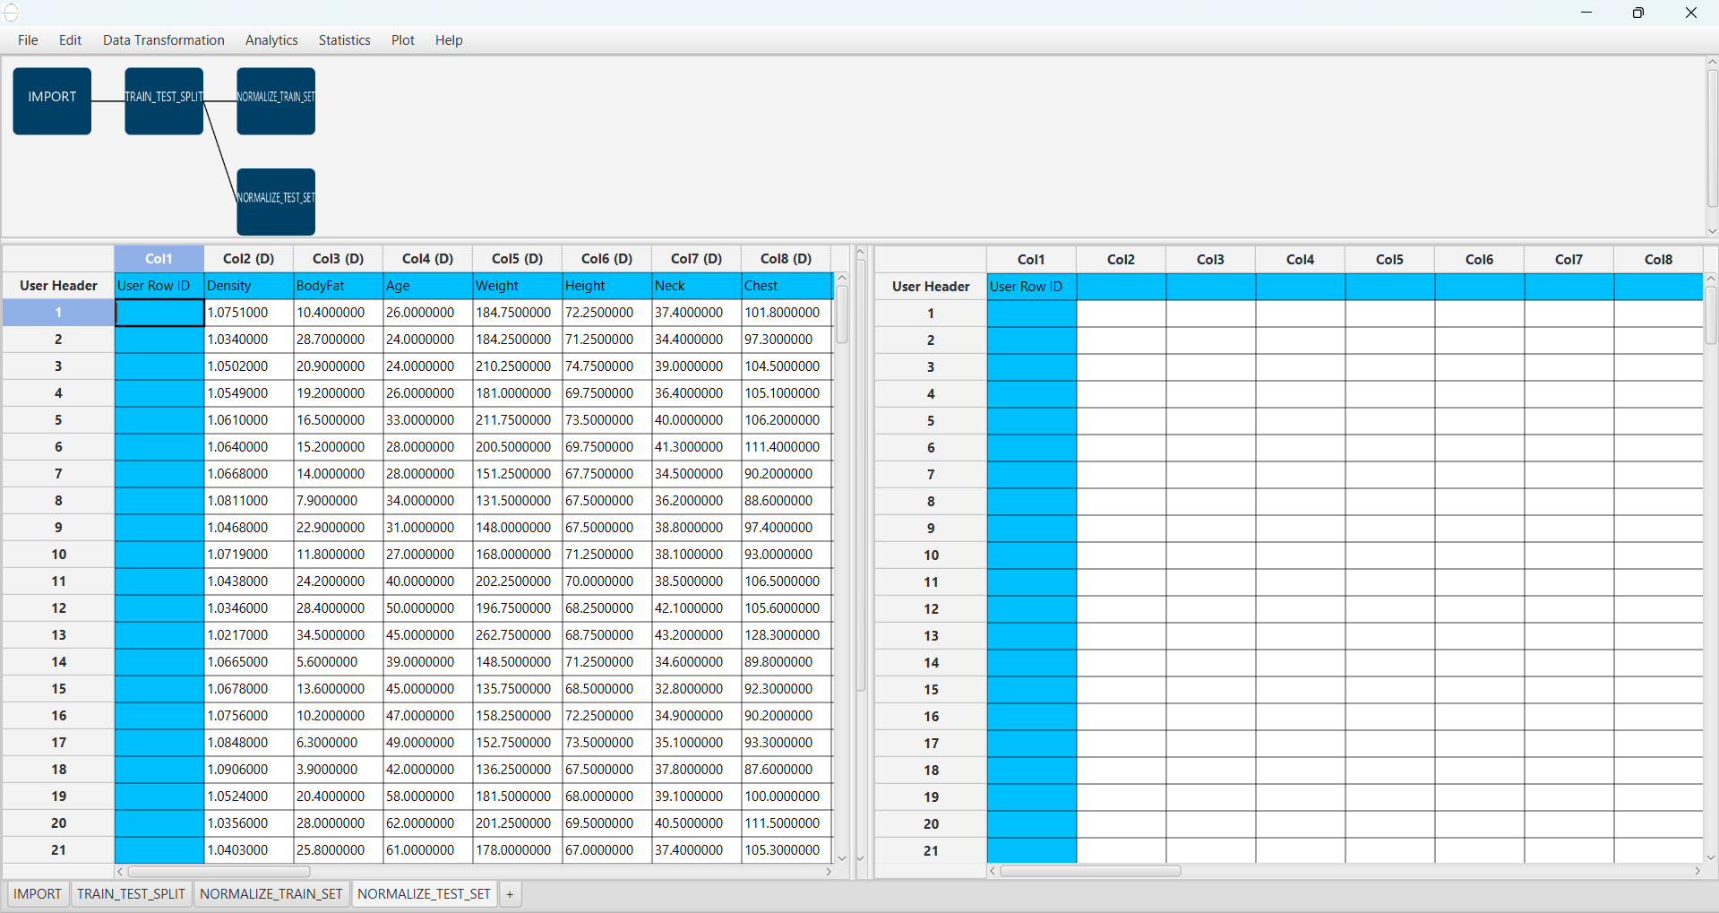

Normalize the test set using the existing normalizer of the training set by browsing:   
“Analytics” → “Existing Model Utilization” → “Model (from Tab:) NORMALIZE_TRAIN_SET”.

|  |  |
| --- | --- |
|  |  |

The results will appear on the output spreadsheet.

# Step 6: Train the model

Create a new tab by pressing the “+” button on the bottom of the page with the name “TRAIN_MODEL(.fit)”. Import data into the input spreadsheet of the “TRAIN_MODEL(.fit)” tab from the output of the “NORMALIZE_TRAIN_SET” tab by right-clicking on the input spreadsheet and then choosing “Import from SpreadSheet”.

Use the k Nearest Neighbors (kNN) method to train and fit the model by browsing:   
“Analytics” → “Regression” → “k Nearest Neighbors (kNN)” and set the “Target Column” as the column corresponding to “BodyFat” and the “Number of Neighbors” to 5.

|  |  |
| --- | --- |
|  |  |

The predictions will appear on the output spreadsheet.

# Step 7: Validate the model

Create a new tab by pressing the “+” button on the bottom of the page with the name “VALIDATE_MODEL(.predict)”.

Import data into the input spreadsheet of the “VALIDATE_MODEL(.predict)” tab from the output of the “NORMALIZE _TEST_SET” tab by right-clicking on the input spreadsheet and then choosing “Import from SpreadSheet”.

To validate the model browse: “Analytics” → “Existing Model Utilization”. Then choose Model “(from Tab:) TRAIN_MODEL (.fit)”. and transfer the “BodyFat” column in the output.

|  |  |
| --- | --- |
|  |  |

The predictions will appear on the output spreadsheet.

# Step 8: Statistics calculation

Create a new tab by pressing the “+” button on the bottom of the page with the name “STATISTICS_ACCURACIES”.

Import data into the input spreadsheet of the “STATISTICS_ACCURACIES” tab from the output of the “VALIDATE_MODEL(.predict)” tab by right-clicking on the input spreadsheet and then choosing “Import from SpreadSheet”.

Calculate the statistical metrics for the regression by browsing: “Statistics” → “Model Metrics” → “Regression Metrics”.

|  |  |
| --- | --- |
|  |  |

The results will appear on the output spreadsheet.

# Step 9: Reliability check of each record of the test set

## Step 9.a: Create the domain

Create a new tab by pressing the “+” button on the bottom of the page with the name “EXCLUDE_BODYFAT”.

Import data into the input spreadsheet of the “EXCLUDE_ BODYFAT” tab from the output of the “NORMALIZE _TRAIN_SET” tab by right-clicking on the input spreadsheet and then choosing “Import from SpreadSheet”.

Manipulate the data to exclude the column that corresponds to the “BodyFat” by browsing: “Data Transformation” → “Data Manipulation” → “Select Columns”. Then select all the columns except the “BodyFat”. The filtered table will appear on the output spreadsheet.

|  |  |
| --- | --- |
|  |  |

Create a new tab by pressing the “+” button on the bottom of the page with the name “DOMAIN”.

Import data into the input spreadsheet of the “DOMAIN” tab from the output of the “EXCLUDE_ BODYFAT” tab by right-clicking on the input spreadsheet and then choosing “Import from SpreadSheet”.

Create the domain of applicability by browsing: “Statistics” → “Domain APD”.

|  |  |
| --- | --- |
|  |  |

The results will appear on the output spreadsheet.

## Step 9.b: Check the test set reliability

Create a new tab by pressing the “+” button on the bottom of the page with the name “EXCLUDE_BODYFAT_TEST_SET”.

Import data into the input spreadsheet of the “EXCLUDE_ BODYFAT _TEST_SET” tab from the output of the “NORMALIZE _TEST_SET” tab by right-clicking on the input spreadsheet and then choosing “Import from SpreadSheet”.

Filter the data to exclude the column that corresponds to the “BodyFat” by browsing: “Data Transformation” → “Data Manipulation” → “Select Columns”. Then select all the columns except “BodyFat”.

|  |  |
| --- | --- |
|  |  |

The results will appear on the output spreadsheet.

Create a new tab by pressing the “+” button on the bottom of the page with the name “RELIABILITY”.

Import data into the input spreadsheet of the “RELIABILITY” tab from the output of the “EXCLUDE_ BODYFAT _TEST_SET” tab by right-clicking on the input spreadsheet and then choosing “Import from SpreadSheet”.

Check the predictions’ reliability by browsing: “Analytics” → “Existing Model Utilization”. Then select as Model “(from Tab:) DOMAIN”.

|  |  |
| --- | --- |
|  |  |

The results will appear on the output spreadsheet. We can observe that there are no unreliable samples in the test set.

# Final Isalos Workflow

Following the above-described steps, the final workflow on Isalos will look like this:

